Tournament Rules
- United States Bowling Congress Rules and Regulations will govern this tournament.
- This tournament is open to all members of USBC chartered Local Associations in the area served by this state. Each member must have in their possession a current USBC membership card. Eligibility for those participants without USBC membership cards for the current season may be established with the purchase of a membership card upon payment of $12.00 National dues, $15.00 state dues and local dues.
- Cash prize winners in team, doubles and singles events will be determined on a handicap basis. The scratch all events winners will be determined on a scratch basis and handicap all events winners will be determined by the 9 games bowled with handicap.. Trophies will be awarded to the high handicap scores in each event including all events in each division. Scratch awards will be awarded to the high scratch in each event including all events for the tournament (everyone in one division). In the event the same team or individual wins both scratch and handicap championship, one set of trophies will be awarded and appropriately engraved. There will be one cash prize for each seven entries or major fraction in each bowled event. There will be one cash prize awarded for each ten entries in both classes of all events hdcp and the optional scratch events. To be eligible for a cash prize in all events, an entry fee of $10.00 for the scratch division and $5.00 for the handicap division must accompany entry. All events may not be transferred to another bowler unless the bowler substitutes in all three events for the same person. Prize fund will be returned 100%. In case of a tie for first place in any event, USBC Rule 326 applies. There will be 2 divisions in every hdcp event. Scratch events will be 1 division.
- Handicap will be 90% of the difference between the bowler’s average and 220 in singles and handicapped all events, the team’s average and 440 in doubles and 1100 in team. NEW For teams in Division 2 they may only have 2 bowlers classified as Division 1 bowlers. If more than 2 Division 1 bowlers they will be classified as Division 1. Bowlers must use their highest USBC or Youth sanctioned final league average of 21 or more games for the 2024-2025 winter season. If no 2024-2025 winter league average, the 2025 summer league average of 21 games or more will be accepted. If no average from last year, use the highest average of 21 or more games as of December 31, 2025. A new bowler without an acceptable average on December 31, 2025, may enter when they reach 21 games before scheduled date of bowling. Any bowler entering the tournament using an average from a “Sports Bowling League” must abide by USBC rule 202. All others will bowl scratch. .
- It shall be each bowler’s responsibility to verify the accuracy of their average whether originally submitted by the bowler, team captain, or others. Failure to use the correct average can disqualify score if submitted average is lower than correct average, thereby resulting in more handicap. Prize winnings will be based on the submitted average if it is higher that the correct average. Corrections in averages can be made up to the completion of the third game of a series.
- USBC Rule 322a for tardy players and USBC Rule 11 for unreasonable delay of games apply to this tournament. (No Smoke breaks)
- Association’s 2024-2025 season yearbooks or Averages listed on Bowl.com are considered official for final averages. All other averages must be certified by the Association Manager.
- State tournament officials will check averages before awarding prize money.
The IRS requires USBC to furnish 1099 forms to individuals who accumulate winnings of $600 or more annually in any USBC events in which they
participate Failure to furnish a Social Security number (U.S. citizens) or Individual Tax ID Number (ITIN) (non-U.S. citizens) to USBC will result in a 30% tax
reduction of the prize check. Prize checks will be distributed within 30 days after the conclusion of the tournament (Rule 309) unless permission is granted to
extend from USBC. Individual checks will be mailed to team captains.
Team captain is to distribute prize money within 30 days of receipt (Rule 304).
- Entry forms must be complete showing all required data including USBC card numbers.
- Entrants may only bowl once in doubles and singles event. Bowlers must bowl both doubles and singles events if entered in either. Bowlers will be allowed to bowl in the team event twice. You must change at least 2 bowlers. First team event will count towards all events. Walk in entries will be accepted for the second team if lanes are available.
- No change in the order of the team or doubles line-ups will be permitted, even though a substitution has been made. Team captains must report to the tournament secretary 30 minutes before scheduled starting time to make changes.
- Score sheets will be available for the bowlers use. Scores will be printed from the center and are considered official. All errors must be claimed within 24 hours after your bowling squad has been completed or the score is official.
- Bowlers need not report previous tournament winnings.
- No more than two (2) members of PBA or PWBA permitted to bowl on five (5) person team. No more than (1) PBA or PWBA member permitted in doubles.
- Unmarried grade and high school students who have not attained the age of eighteen (18) may participate in this tournament if they purchase adult membership.
- In the event a game (or portion of a game) is irretrievably lost in the scoring process, the game (or portion thereof) shall be rebowled at a time and date determined by tournament management. Should the time and date of rebowling be refused by the participant, the State Tournament Director is liable only for the return of the entry fee paid for the event in which the loss occurred (including all events entry, if applicable)
- Refunds: Entry fees will not be refunded except when Nebraska USBC notifies an entrant of dates and times assigned and a refusal has been received by Nebraska USBC in writing within 10 days of the date of the confirmation notice.
- Dress Code: Clothing with derogatory, offensive or suggestive language will not be permitted. Examples of prohibited attire include tank tops, muscle shirts, halter tops, bare midriffs, spaghetti strap tops, short shorts, short skirts, sweat or lounge pants, or jeans that are not neat, clean or in good condition. Bowlers will be required to change if attire is deemed inappropriate by tournament management or designees. Tournament management or designee decision will be final.
  - 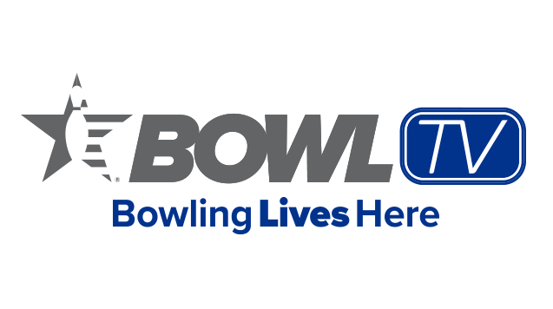
Mail Entries and Fees To:

NEBRASKA USBC OPEN TOURNAMENT
DIRECTOR, GARY HATCHER
PO BOX 594
GIBBON, NE 68840
PHONE: 308-238-3914
MAKE CHECKS OR MONEY ORDERS PAYABLE TO NEBRASKA OPEN BOWLING TOURNAMENT
A fee of $30.00 will be charged for all return checks.
Entry Fees
eVENT | lINEAGE & eXPENSES | pRIZE | tOTAL
Team | $91.75 | $58.25 | $150.00
Doubles | $36.70 | $23.30 | $60.00
Singles | $18.35 | $11.65 | $30.00
ALL EVENTS SCRATCH (Optional)
 | $1.00 | $9.00 | $10.00
All events handicap
 | $1.00 | $4.00 | $5.00
Singles Dbls, & Team Scratch (Optional) Per Bowler Per Event
 | $1.00 | $9.00 | $10.00

